Data Representation

Lab 06.01: Use Python to access Server

Lecturer: Andrew Beatty

In this lab we are going to use Python to access the server we used in week05 via the API.

|  |  |  |  |  |
| --- | --- | --- | --- | --- |
| Action | Method | URL | Sample params | Sample return |
| Get all | GET | /cars | none | {  cars:[  {…},{…},{…}  ]  } |
| Find by id | GET | /cars/*reg* | none | {car:  {  "reg":"12 D 1234",  "make":"Fiat",  "model":"Punto",  "price":3000  }  } |
| Create | POST | /cars | {  "reg":"12 D 1234",  "make":"Fiat",  "model":"Punto",  "price":3000  } | {  "reg":"12 D 1234",  "make":"Fiat",  "model":"Punto",  "price":3000  } |
| Update | PUT | /cars/*reg* | {  "price":3000  } | {  "reg":"12 D 1234",  "make":"Fiat",  "model":"Punto",  "price":3000  } |
| delete | DELETE | /cars/*reg* | none | {  "done":true  } |

To do this you must make sure that your server is running

python b_restserver.py

* Serving Flask app "b_restserver" (lazy loading)

* Environment: production

WARNING: This is a development server. Do not use it in a production deployment.

Use a production WSGI server instead.

* Debug mode: on

* Running on http://127.0.0.1:5000/ (Press CTRL+C to quit)

* Restarting with stat

* Debugger is active!

* Debugger PIN: 388-436-605

1. Write a python program that will get all the cars from the server (using the API).

import requests

url = "http://127.0.0.1:5000/cars"

response = requests.get(url)

data = response.json()

#output to console

print (data)

* 1. The program should output the returned json to the screen.
  2. The program should output all the cars individually to the screen.
  3. The program should write the returned JSON neatly to a file.

for car in data["cars"]:

    print (car)

* 1. The program should write the cars to an EXCEL file.

from xlwt import *

#other code

# write to excel file

w = Workbook()

ws = w.add_sheet('cars')

row = 0;

ws.write(row,0,"reg")

ws.write(row,1,"make")

ws.write(row,2,"model")

ws.write(row,3,"price")

row += 1

for car in data["cars"]:

    ws.write(row,0, car["reg"])

     ws.write(row,1,car["make"])

     ws.write(row,2,car["model"])

     ws.write(row,3,car["price"])

    row += 1

w.save('cars.xls')

import json

#other code

#save this to a file

filename = 'cars.json'

if filename:

    # Writing JSON data

    with open(filename, 'w') as f:

        json.dump(data, f, indent=4)

Result –

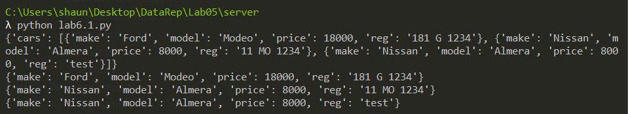

And cars excel file also uploaded to Github

1. Write a python program that creates a car on the server by using the API

import requests

import json

dataString = {'reg':'08 C 1234','make':'Ford','model':'Galaxy','price':12324}

url = 'http://127.0.0.1:5000/cars'

response = requests.post(url, json=dataString)

print (response.status_code)

1. Write a python program that updates a car on the server using the API.

import requests

import json

dataString = {'make':'Ford','model':'Kuga'}

url = 'http://127.0.0.1:5000/cars/test'

response = requests.put(url, json=dataString)

print (response.status_code)

print (response.text)

1. Write a python program that deletes a car from the server using the API.

import requests

url = 'http://127.0.0.1:5000/cars/08%20C%201234'

response = requests.delete(url)

print (response.status_code)

print (response.text)

## Challenge read from github:

1. Create a spread sheet that gets all the users that are following me (datarepresentationcourseware) and outputs the users login and repos URL to a spreadsheet.
   1. Get the list from the the github API and output to the console (messy)
   2. Then output it to a file neatly

import requests, json

#url = "https://api.github.com/users?since=100"

url = "https://api.github.com/users/andrewbeattycourseware/followers"

response = requests.get(url)

data = response.json()

#print(data)

#Get the file name for the new file to write

filename = 'githubusers.json'

with open(filename, 'w') as f:

    json.dump(data, f, indent=4)

* 1. Now you have to work out how you would write this to excel

2. Result –

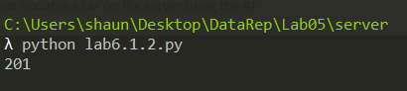

3. Result –

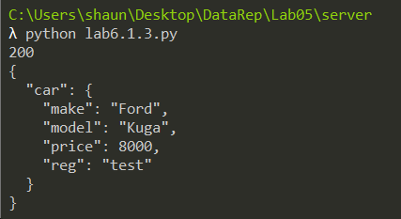

4. Result –

